BottomSheet with Tabbar

Exercise #1

Flutter Developer Bootcamp

# **Purpose**

This exercise demonstrates how to implement a bottom sheet in a Flutter application using the showModalBottomSheet function and Tab bar view.

**Problem**

In the provided Exercise You need to create as follows:

In the given exercise showcases a tabbed interface with three tabs: "Chats", "Calls", and "Settings". Each tab displays its respective content, with the "Chats" tab demonstrating a button that triggers a modal bottom sheet. The bottom sheet presents a simple layout with a height of 200 and an amber background, containing a "Modal BottomSheet" text and a button to close it. This setup effectively demonstrates the implementation of a bottom sheet within a Flutter application.

**How to Solve**

1. Checkout the exercise from Git Repo:

git clone -b <user-branch> <repo-URL>

2. Open the root folder inside VS Code

3. To build the app click the run option in the main method{}

4. Define Tabs: Define the tabs you want to include in your application. You can use the TabBar and TabBarView widgets to create a tabbed interface. Each tab will have its own content.

5. Add Content for Each Tab: Define the content for each tab. This can include widgets like Text, ListView, GridView, or custom widgets depending on your requirements.

6. Implement Modal Bottom Sheet: For the tab that should trigger a modal bottom sheet, create a button or any other user interaction that, when pressed, invokes the showModalBottomSheet function. Inside the builder function of showModalBottomSheet, define the content of your modal bottom sheet.

8. Customize Appearance: Customize the appearance of your tabs, app bar, and bottom sheet as needed. You can adjust colors, fonts, and other visual properties to match your design.

9. Go To File: <specific-file-with-bottomsheet-method> à <method-name>, implement your logic.

**You will Achieve**

When you complete this Exercise you will learn the following:

* **Tabbed Interface**: Implement a tabbed interface with three tabs: "Chats", "Calls", and "Settings". This is achieved using the DefaultTabController, TabBar, and TabBarView widgets.
* **Bottom Sheet Functionality**: Implement a bottom sheet that appears when a button is pressed. The bottom sheet contains a brief message and a button to close it. This is accomplished using the showModalBottomSheet function.
* Widget Imports:
* **MaterialApp**: For setting up the root widget of the application.
* **DefaultTabController**: To manage the tab controller for the tabbed interface.
* **Scaffold**: Provides the basic material design visual layout structure.
* **AppBar**: Represents the app bar at the top of the screen.
* **TabBar**: Displays a horizontal row of tabs.
* **TabBarView**: Displays the content corresponding to each tab.
* **Center**: Centers its child within itself.
* **ElevatedButton**: A button with a filled background color.
* **Text**: Displays text.
* **showModalBottomSheet**: Displays a modal bottom sheet.

By incorporating these widgets and functionalities, you'll create a Flutter application with a tabbed interface and modal bottom sheet functionality.

# **Screenshots**

## **Expected output(with bottomsheet and tab bar)**

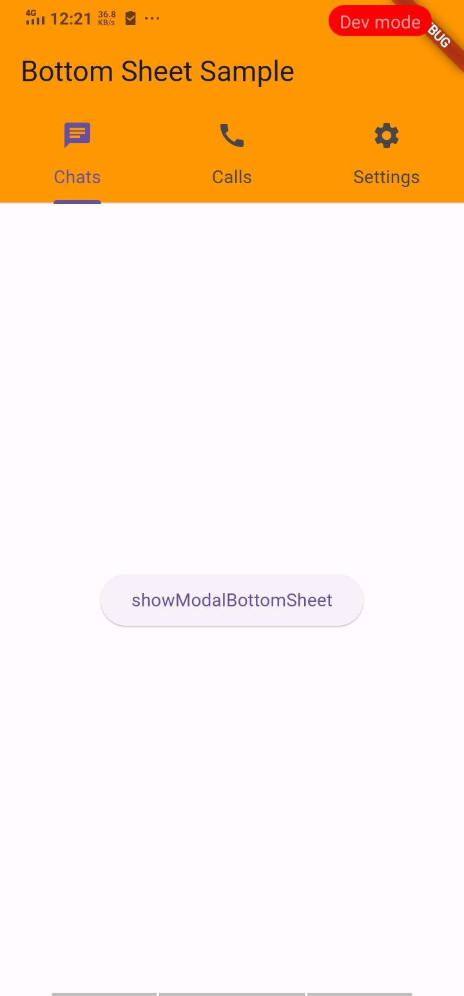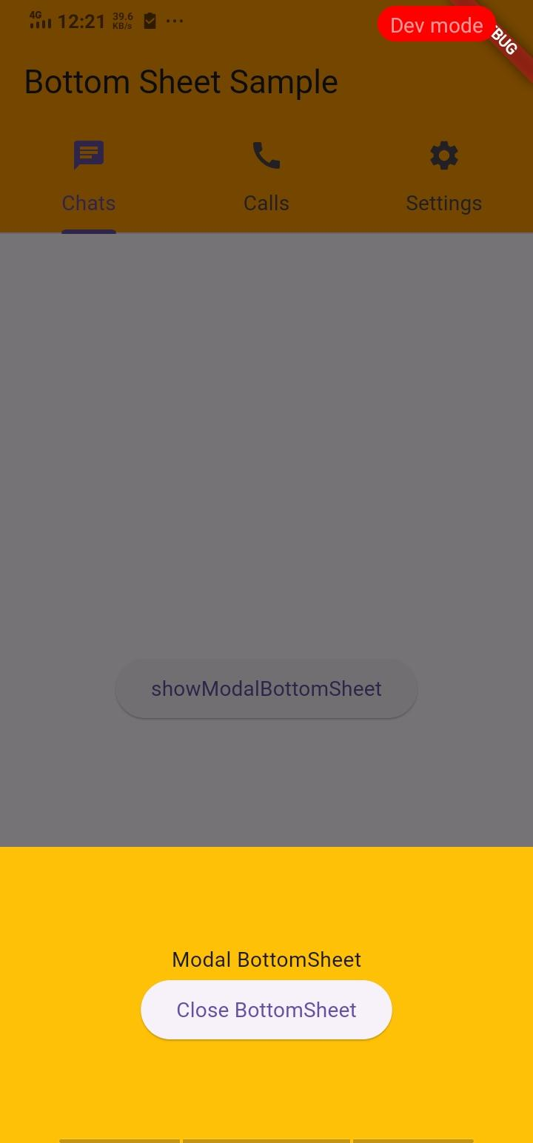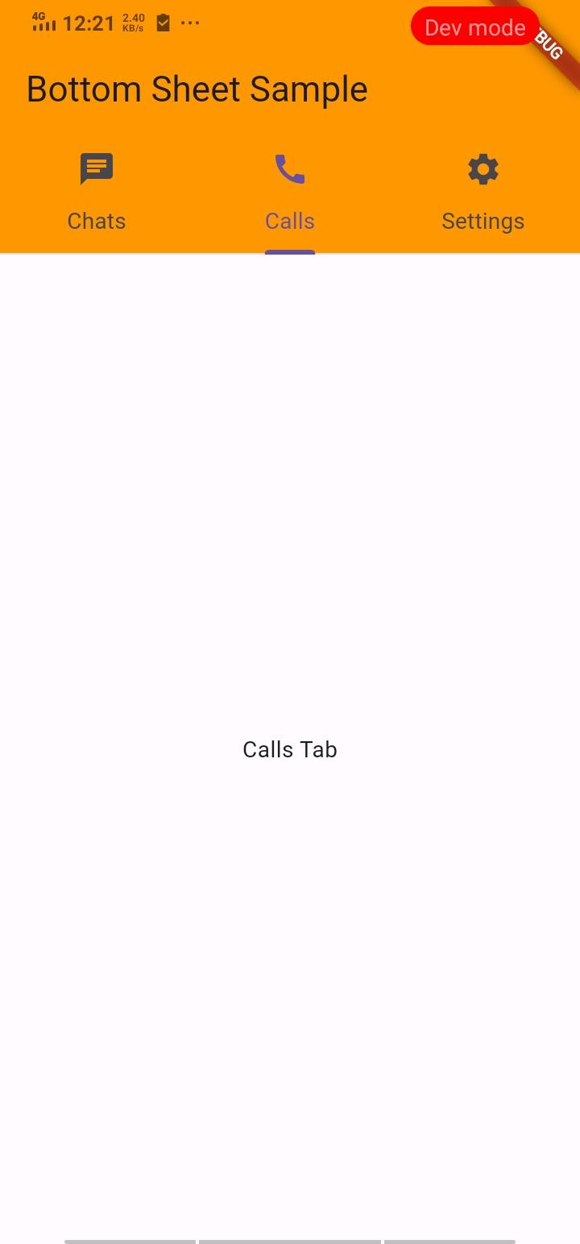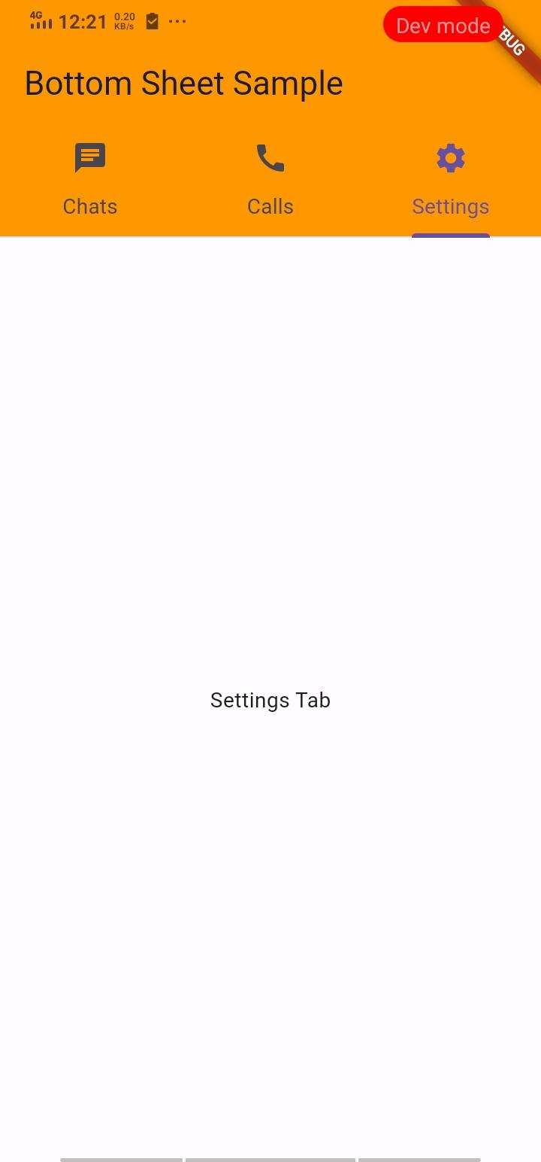

## 

# **How to submit your Exercise**

Push your project back to the same git branch using command:

<command name>

# **Happy Coding!**